**Wireless Intruder Alert System**

Submitted in partial fulfillment for the award of the degree of

**Bachelor of Technology**

**In**

**Electronics And Communication Engineering**

Submitted to

**VIT BHOPAL UNIVERSITY (M.P.)**



**Submitted by**

**B.S Govinddarajan 20BEC10015,**

**Krapansh Shrivastava 20BEC10016,**

**Siddhartha Singh 20BEC10020,**

Under the Supervision of

Dr. Abhay Vidhyarthi

**SCHOOL OF ELECTRICAL & ELECTRONICS ENGG.**

**VIT BHOPAL UNIVERSITY**

**BHOPAL (M.P.)-466114**

**April –2022**



**VIT BHOPAL UNIVERSITY BHOPAL (M.P.) 466114**

SCHOOL OF ELECTRICAL & ELECTRONICS ENGG.

**CANDIDATE’S DECLARATION**

I hereby declare that the Dissertation entitled “Wireless Intruder Alert System" is my own work conducted under the supervision of Dr. Abhay Vidhyarthi, Electronics and Communication at VIT University, Bhopal.

I further declare that to the best of my knowledge this report does not contain any part of work that has been submitted for the award of any degree either in this university or in other university / Deemed University without proper citation.

**B.S Govinddarajan 20BEC10016,**

**Krapansh Shrivastava 20BEC10016,**

**Siddhartha Singh 20BEC10020,**

This is to certify that the above statement made by the candidate is correct to the best of my knowledge.

Dr. Abhay Vidhyarthi

Designation

--------------------------------------------------------

Digital Signature of Guide



**VIT UNIVERSITY BHOPAL (M.P.) – 466114**

SCHOOL OF ELECTRICAL & ELECTRONICS ENGG.

**CERTIFICATE**

This is to certify that the work embodied in this Project Exhibition -1 report entitled **“Wireless Intruder Alert System”** has been satisfactorily completed by **Ms. /Mr. B.S Govinddarajan, Krapansh Shrivastava, Siddhartha Singh** Registration No: 20BEC10015, 20BEC10016, 20BEC10020 respectively in the School of Electrical & Electronics Engineering at VIT University, Bhopal. This work is a bonafide piece of work, carried out under my/our guidance in the School of School of Electrical & Electronics Engineering for the partial fulfilment of the degree of Bachelor of Technology.

--------------------------------------

**Name of Co-guide Name of Guide : Dr. Abhay Vidhyarthi Designation Designation**:

Forwarded by Approved by

**Name of Program Chair Name of Dean**

**Program Chair Professor & Dean**

**Acknowledgement**

We would like to thank Dr. Abhay Vidhyarthi of VCS College, for their cooperation and guidance in completing our project Wireless Intruder Alert System

I would like to take this opportunity to express my gratitude to all of my group members B.S Govinddarajan, Krapansh Shrivastava, Siddhartha Singh. We would not have been able to complete this project without their help and cooperation.

**Executive Summary**

The intruder detection system is designed for private areas, restricted areas, and domestic home applications to alert the intruder or any person who enters the specified areas. The intruder detection system prevents theft and unauthorised entry into restricted areas by notifying the owner or gardener via the registered application when the system detects an intruder in the area. In this paper, an IoT-based intruder detection system is proposed to prevent people from entering the target location without the use of specialised personnel.

**Table of Contents**

Front Page ii

Candidate’s Declaration iii

Certificate iv

Acknowledgement v

Executive Summary vi

List of Figures vii

List of Tables viii

List of Symbols & Abbreviations ix

Contents Page No.

1. **INTRODUCTION**
2. **LITERATURE REVIEW**
3. **PROBLEM FORMULATION AND PROPOSED METHODOLOGY.**

**4 RESULTS AND DISCUSSION**

**5 CONCLUSION AND FUTURE SCOPE**

**REFERENCES**

**INTRODUCTION**

In these days, where life is rapidly progressing, one's personal security and privacy have dwindled dramatically. Obtaining a safe place for human habitation has become increasingly difficult, as evidenced by the increasing number of theft cases. These incidents are more common in private properties, small towns, and single-family homes. People prefer manual security methods such as traditional alarm systems. However, this has resulted in failure.

“Wireless Intruder Alert System” is an automated system that uses a microcontroller and an ultrasonic sensor or pir sensor. This will be attached at the entrance to any private place, such as a house. When a suspicious person enters the house when no one is present, a notification is immediately sent to the owner's mobile phone.

**LITRETURE REVIEW**

* Several Intruder Detection Systems have been proposed over the last decade to address the security issue of intruders entering homes. These intrusion detection systems are actively detecting the intrusion of an unknown person or thief and recognising the owners of the house.
* Nico Surantha et al. proposed a detection system design with a motion sensor and a camera connected to a Raspberry Pi, and the SVM identifies suspicious objects or people approaching the door.
* Suzi Seroja Binti Sarnin, Divine Senanu Ametefe in year 2019 gave the solution to the problem of LPG leakage problem, they used sensors for the detection and used node mcu esp8266 as the wireless module for the wireless transmission MQ-2 gas sensor was used for the detection of LPG gas leakages, the monitoring aspect was satisfied locally through notifications triggered by LEDs, piezo buzzer and remotely through the use of an application known as Blynk.
* k.Lova Raju, V chandrani, SK Shahina Begum in 2019 proposed and idea of home automation and security system, to control lights, fans and other home appliances which are connected to the relay system, the system offers switching functionalities. It is also used for environmental monitoring by sensing and analysing data about temperature and humidity. Another notifying feature in this system designed is the intrusion detection which is offered by this system using motion sensor. All these activities are controlled by using Android mobile app-Blynk.
* Ravi Kishore Kodali, Venkata Sandeep kumar Gorantala in 2018 gave a project called RESTful Motion Detection and Notification using IoT, This paper mainly focuses on detection of motion in a particular area and if it is detected a notification will be sent to the person. In current implementation the PIR sensor is integrated to low-cost and Wi-Fi enabled NodeMCU Microcontroller in order to detect the motion.The NodeMCU posts the information to Thinger.io cloud which uses RESTful Programming Interface for easy integration of components.

**PROBLEM FORMULATION AND PROPOSED METHODOLOGY**

PIR motion sensors are installed at building entrances. As previously stated, these sensors detect human motion. This signal, which detects their presence, becomes the ESP 8266's input trigger. A alert will be received on the owner's mobile phone, who may or may not be present in that building. The connectivity between the ESP8266 (WiFi module) and the Blynk server is another critical component of the project. Using the authentication token and the Blynk libraries, the system successfully connected to the Blynk server. As a result, we were able to receive notifications on our smartphones whenever the status of the pir sensor changed.

**BLOCK DIAGRAM**

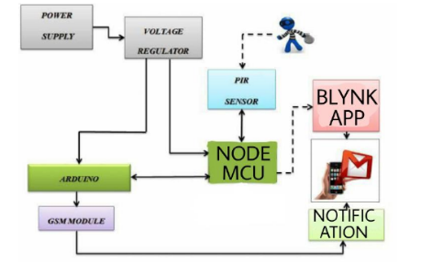

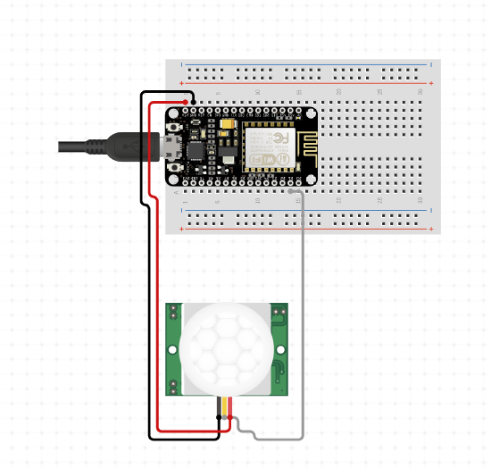

**NODE MCU**

The NODE MCU board includes the ESP-12E module, which contains an ESP8266 chip with a tensilica xtensa 32-bit LX106 RISC microprocessor [9]. The microprocessor supports Real Time OS and has a clock frequency of 80MHz-160MHz. To store data and programmes, the MCU has 128kb of ram and 4mb of flash memory. Its high processing power combined with built-in WIFI / Bluetooth makes it ideal for IoT projects. The micro USB jack can be used to power the MCU.



**CONCLUSION**

The sensors installed on the door send a Push notification to the home owner as soon as the door is opened. The user will receive this notification regardless of whether the phone is locked or unlocked, or if any other app is currently open. This was the project's primary goal. This configuration can also be used in commercial offices where certain areas are restricted to specific personnel; such a system will immediately notify the administrator of any unauthorised personnel attempting to access such an area. The developed system can also be used in industrial and commercial applications such as offices, warehouses, and other areas where some areas are restricted to authorised personnel only, as well as other places where safety is a concern.

**REFERENCES**

[1]. Arisandi, D., M. Elveny, and R. Rahayu. "Human

Detection and Identification for Home

Monitoring System." In Journal of Physics:

Conference Series, vol. 1898, no. 1, p. 012026.

IOP Publishing, 2021.

[2]. Abdulla, Abdulrahman Ihsan, Ahmad Sinali

Abdulraheem, Azar Abid Salih, M. A. Sadeeq,

Abdulraheem Jamel Ahmed, Barwar M. Ferzor,

Omar Salih Sardar, and Sarkaft Ibrahim

Mohammed. "Internet of things and smart home

security." Technol. Rep. Kansai Univ 62, no. 5

(2020): 2465-2476.

[3]. Adriano, Davin Bagas, and Wahyu Apsari

Ciptoning Budi. “IoT-based Integrated Home

Security and Monitoring System.” In Journal of

Physics: Conference Series, vol. 1140, no. 1, p.

012006. IOP Publishing, 2018.

[4]. Nico Surantha and Wingky R. Wicaksono. “An

IoT based House Intruder Detection and Alert

System using Histogram of Oriented Gradients”.

Journal of Computer Science 2019, 15 (8):

1108.1122.

[5]. Wahyuni, Refni, Aditya Rickyta, Uci Rahmalisa,

and Yuda Irawan. "Home security alarm using

Wemos D1 and HC-SR501 sensor based telegram

notification." Journal of Robotics and Control

(JRC) 2, no. 3 (2021): 200-204.

[6]. Anwar, Shaik, and D. Kishore. "IOT based smart

home security system with alert and door access

control using smart phone." International Journal

of Engineering Research & Technology (IJERT)

5, no. 12 (2016): 504-509.

[7]. Nwalozie, G. C., A. N. Aniedu, C. S. Nwokoye,

and I. E. Abazuonu. "Enhancing home security

using SMS-based Intruder Detection System."

International Journal of Computer Science and

Mobile Computing 4, no. 6 (2015): 1177-1184.